ATCHAFALAYA BASIN LEVEE DISTRICT
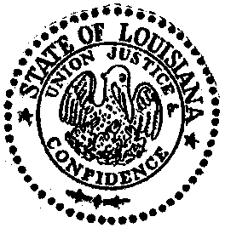
P. O. Box 170
Port Allen, Louisiana 70767-0170
Phone (225) 387-2249
Fax (225) 387-4742

Certification of Meeting Conducted Pursuant to La. R.S. 42:17.1

In accordance with R. S. 42:17.l this notice shall serve as certification of the Atchafalaya
Basin Levee District’s inability to otherwise operate in accordance with the Louisiana Open
Meetings Law due to such a meeting being detrimental to the health, safety, and/or welfare
of the public as a result of the public health emergency, as declared by Governor John Bel
Edwards on August 4, 2021, by Proclamation Number 137 JBE 2021.

The Atchafalaya Basin Levee District will provide for attendance at its essential government
meeting on January 12, 2022 via telephone conference. It is essential that the Atchafalaya
Basin Levee district continue to operate to address matters directly related to its response to
the disaster or emergency and/or matters that if delayed will cause a curtailment of vital
public services or severe economic dislocation and hardship and/or matters that are critical
to the continuation of its business and that are not able to be postponed due to legal
requirements and/or other matters that presiding officer has determined are critical or time-
sensitive.

Considering the foregoing, and in accordance with R.S. 42:17:1 and, Proclamation Number 137 JBE 2021, the Atchafalaya Basin Levee District meeting on January 12, 2022 will be held via telephone conference and in a manner that will allow for observation and input by members of the public, as set forth below.

The meeting may be observed by dialing 1- 571-748-4021 and entering Pin Number 991 0983#.
Members of the public may submit public comment on an agenda item by sending an email
to info@abldla.com or by sending a fax to 225-387-4742 no later than 3:00 p.m. on
January 12, 2022. All public comments will be properly identified and acknowledged during
the meeting.

Certified this 5th day of January, 2022

_______________________________
John Grezaffi, President

